Insert Title of Your Paper Here (Please Use Capital Letters at the Beginning of Each Word)
Title Firstname Name_Author1 [ = Speaker]; Title Firstname Name_Author2 [style format: ‘Authors’]
Company1, City of Location, Country [style format: ‘Company’]
Title Firstname Name_Author3; Title Firstname Name_Author4
Company2, City of Location, Country [use the second paragraph only if authors are not from the same company or location like the authors listed above]
Contact: contact@company.com [if desired, insert email address of contact person for questions concerning the paper]

Content
1 Heading 1 2
3 Pictures and Graphics 3
4 Tables 4
5 Formulas 4
6 Lists 4
6.1 Ordered lists 4
6.2 Unordered lists 5
7 Abbreviations 5
8 References 5
Please insert an automatic table of content at the beginning of your paper. It provides a better overview of the document and one can simply access the individual chapters by clicking on their heading in the table.

Summary
This template contains styles for the different parts of the text, which need to be used to format your manuscript. Styles include for example headings, pictures and descriptions, subscript and superscript for numbers, lists, etc. You can find the complete list of styles by clicking on the button marked by the red arrow:
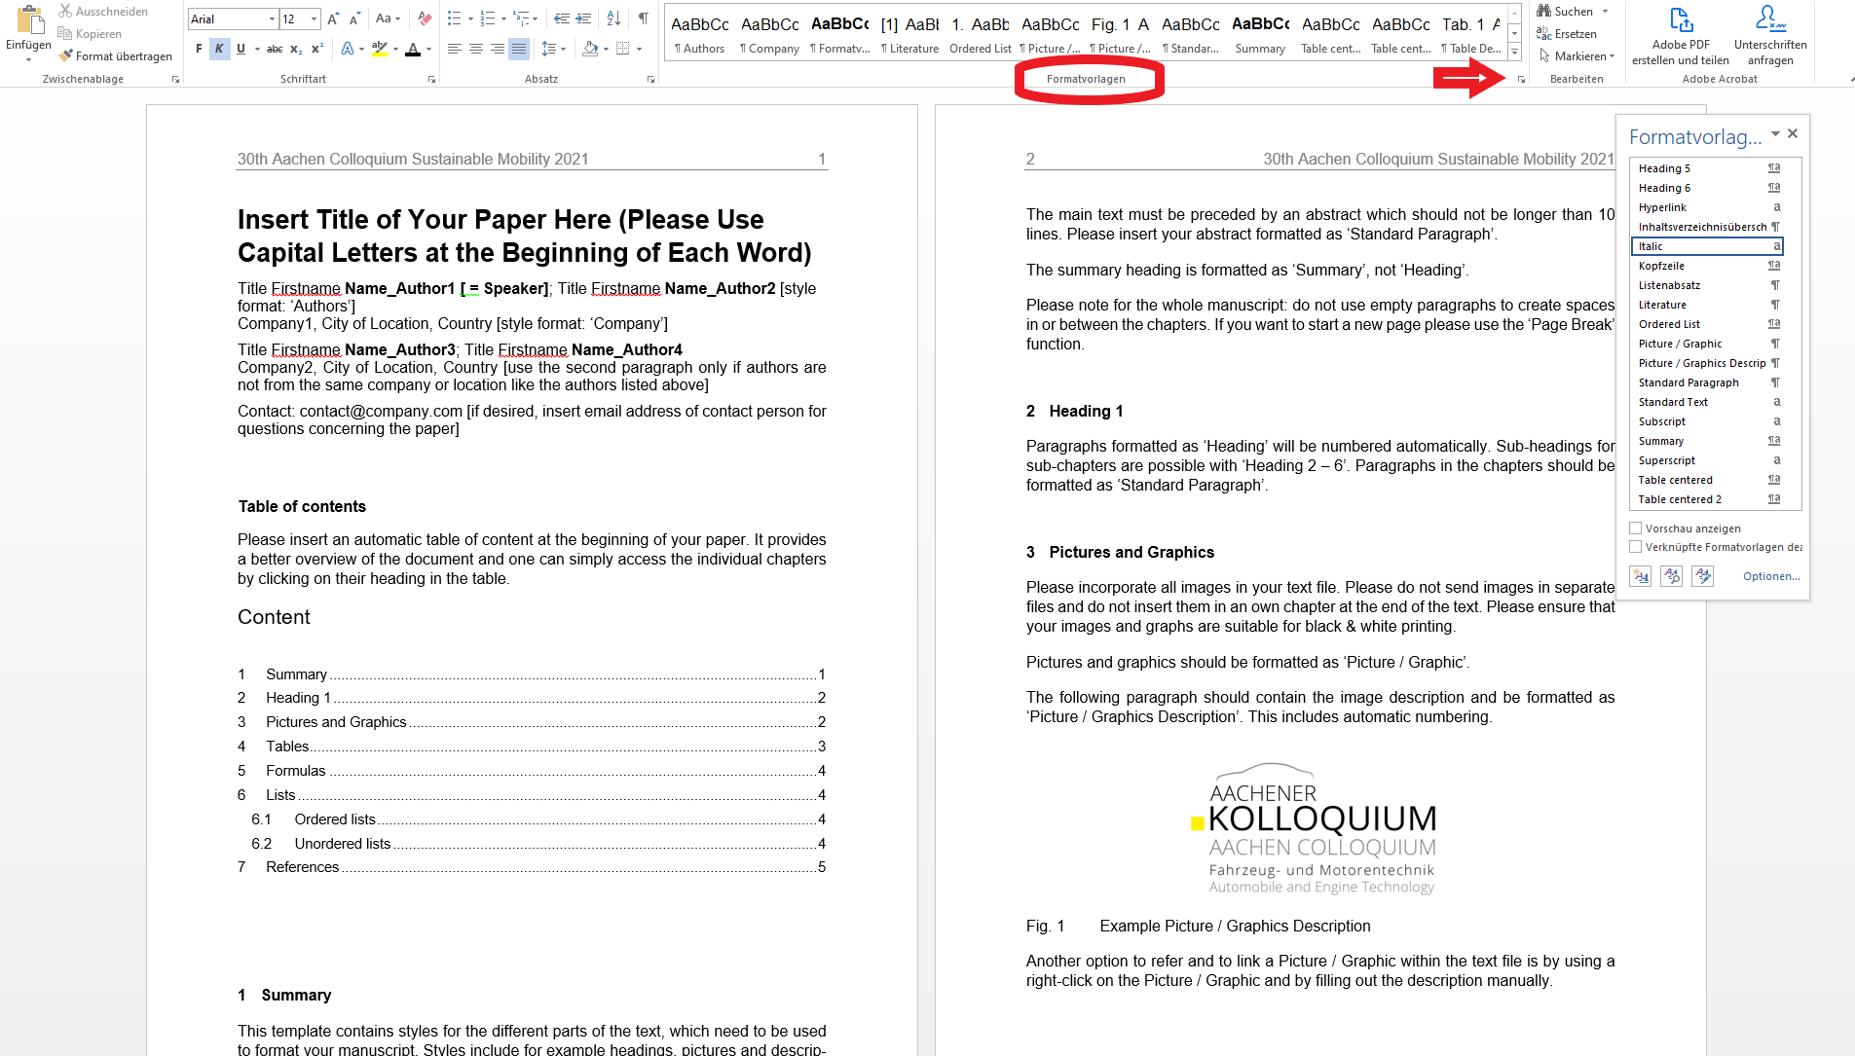
The main text must be preceded by an abstract which should not be longer than 10 lines. Please insert your abstract formatted as ‘Standard Paragraph’.
The summary heading is formatted as ‘Summary’, not ‘Heading’.
Please note for the whole manuscript: do not use empty paragraphs to create spaces in or between the chapters. If you want to start a new page please use the ‘Page Break’ function.

Heading 1
Paragraphs formatted as ‘Heading’ will be numbered automatically. Sub-headings for sub-chapters are possible with ‘Heading 2 – 6’. Paragraphs in the chapters should be formatted as ‘Standard Paragraph’.

Pictures and Graphics
Please incorporate all images in your text file. Please do not send images in separate files and do not insert them in an own chapter at the end of the text. Please ensure that your images and graphs are suitable for black & white printing.
Pictures and graphics should be formatted as ‘Picture / Graphic’.
The following paragraph should contain the image description and be formatted as ‘Picture / Graphics Description’. This includes automatic numbering.
- Example Picture / Graphics Description

You can also refer to a picture or graphic in your text by using a cross-reference, e.g. ‘See Figure 1 for the logo of the Aachener Colloquium for Sustainable Mobility’.
Click ‘Cross-reference’ on the ‘Insert’ tab. In the ‘Reference type’ box, choose from the drop-down list what you want to link to. In the ‘Insert reference’ to box, click on the information you want inserted in your document. Afterwards, click on the specific item you want to refer to in the ‘For which’ box. To allow the readers to jump to the referenced item, click on the ‘Insert as hyperlink’ check box. Click ‘Insert’.
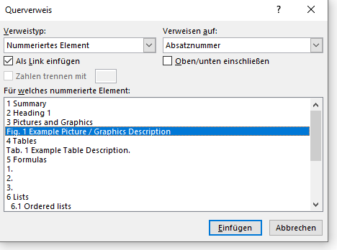

Tables
Tables should be preceded by a description paragraph formatted as ‘Table Description’. This includes automatic numbering.

- Example Table Description.
Use the format "Table centered" for centered text in tables with space before and after the text
Use the format "Table centered 2" for centered text in tables without space before and after the text

Formulas
Please use the following, frameless table to present your formulas. You can simply copy the table. Insert your formula in the left column with the Equitation Editor. In the right column, automatic numbering should be formatted as ‘Formula Description’.
$$E=m∙c²$$

$$F=m∙a$$

Lists

Ordered lists
To create ordered lists please use the ‘Ordered List’ format
- First entry
- Second entry
- …

Unordered lists
To create unordered lists please use the ‘Unordered List’ format
- First entry
- Second entry
- …
Spaces before and after the list will be created automatically

Abbreviations
CO₂ Carbon dioxide
DoE Design of Experiments
EM E-Motor
HV High voltage
SUV Sport Utility Vehicle
WJ Water jacket
ICE Internal combustion engine

References
Please use the following pattern to list all your references. Note: each reference is one paragraph. Inside the paragraphs a line break is used to start the new line (use shift+return on the keyboard). The paragraphs are formatted as ‘Literature’ and the numbering will be created automatically.
- Name1, First Name1, Name2, First name2, and Name3, First name3, 20xx.
Title of the book. xth Edition.
Place: Publisher.
ISBN
- Name1, First Name1, Name2, First name2, and Name3, First name3, 20xx.
Title of the conference paper.
In: Name of conference. Place, time of conference.
Place of publisher: Publisher, pages x-y.
ISBN/doi
- Name1, First Name1, Name2, First name2, and Name3, First name3, 20xx.
Title of the paper.
In: Title of journal. Edition, pages x-y.
ISSN/doi

